RECIPE  
Poke Bowl

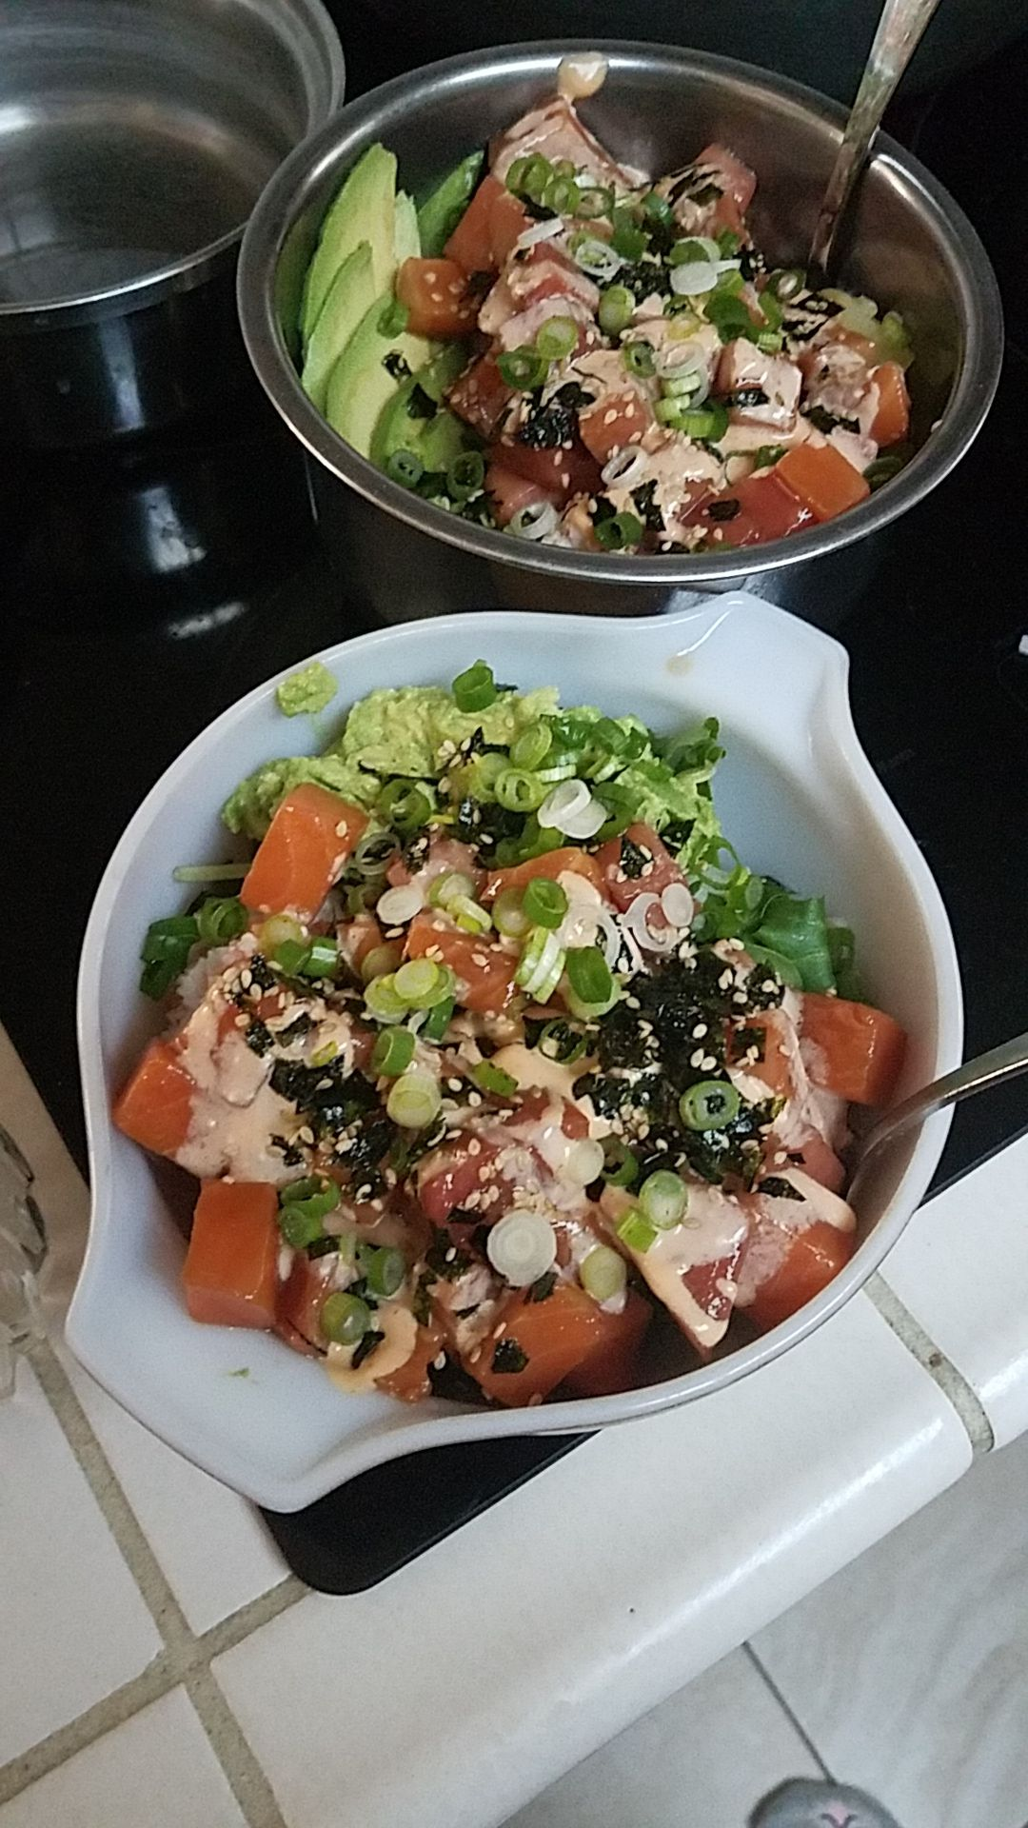

Makes **4 Bowls**

***\*Poke bowls are completely customizable the ones in italics are ones I haven’t tried yet but you might like!\****

# Ingredients

**For the Spicy Aioli Sauce:**

* ½ cup Mayo
* 3 1/2 tbsp Sriracha
* 2 tbsp Lime
* 5 tsp Honey
* Few drops Sesame seed oil

**For the Vinaigrette:**

* 1tbsp Lime
* 2tbsp Soy sauce
* 2tbsp Rice vinegar
* 2tbsp Olive oil
* 1 tbsp Sesame oil
* 1 tbsp Honey

**For the Bowl:**

* Salmon
* Tuna
* 1 cup Brown Rice
* ~ 4 cups Spring Mix
* Imitation crab meat and mayo mix

**For the toppings:**

* Pickled ginger
* 2 Avocados, either mashed or sliced
* Seaweed sesame seed mix
* 2 Scallions sliced
* 2-3 thin slices of onion
* *\*Seaweed salad\**
* *\*Pineapple chunks and/ or mango\**
* *\*Edamame\**
* *\*Cucumber slices\**

# Preparation

1. **Thaw your fish.** When it is still partly frozen, cut it up into small bite sized cubes, and return it to the refrigerator until completely thawed.
2. **Assemble the vinaigrette.** Put all the ingredients for the vinaigrette into a mason jar and shake. Let it sit in the refrigerator to develop flavor as you put together the rest of your bowl ingredients**.**
3. **Cook your rice** according to the directions on the bag. Usually it needs to cook on the stove for 40-50 mins.
4. **Prep the crab meat,** cutting it up small and adding in enough mayo that it will stick together in a ball. If it needs more flavor you can add a bit of lime/ lemon juice.
5. **Make your spicy aioli sauce**, as your rice cooks in a small container mixing together all the ingredients. If you want it spicier, add more sriracha. If you want it sweeter add more honey.
6. **Prepare your toppings,** slice up your onions, scallions, mangos and cucumbers. Slice or mash your avocados. Cut up your seaweed sheets into strips or bits and mix with sesame seeds. Prep your edamame and if you want you can cut up your ginger into small pieces. To mix better in the bowl.
7. **Assemble your bowl!** Place your rice and spring mix at the bottom of your bowl. In a separate bowl, take your fish, and mix it into the vinaigrette, then put it all in the bowl. Scoop in your crab meat, and avocado, fruit and onion, ginger, edamame, seaweed salad etc. Then top with the aioli sauce, seaweed and sesame seed mix, and scallions. Enjoy!